### **Thanksgiving Headdresses**

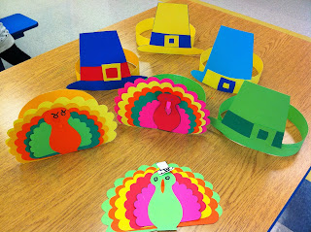

Headdresses made by students

I remember as a child in first grade making Thanksgiving headdresses. I made a few versions. I have made two types of turkeys with different feathers, a pilgrim hat, and an Indian headdress.

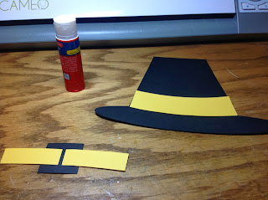

Slide buckle through the smaller band and attach to the larger band

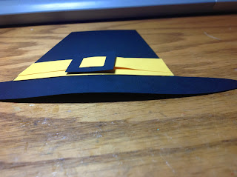

I used a glue stick to glue the buckle on. Bend the paper a little to conform

to the curvature of your head.

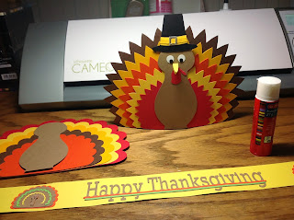

I used a glue stick to glue all of the parts. It makes the paper

pliable so that you can bend it a little.

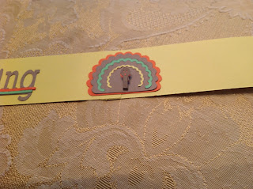

The little turkey on the Happy Thanksgiving headband is 3D.

The head protrudes a little. There are perforations to where it bends. The different colors were made by cutting different feathers and interchanging the parts.

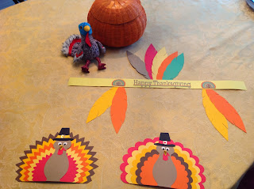

I added feathers to the Indian headdress.

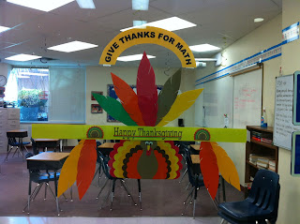

I used the decorations as a Thanksgiving window dressing at school.